Project Design Phase-II
Data Flow Diagram & User Stories

Date | 29 June 2026
Name | VARSHINI S
Project Name | Metro Ticket Generating System in ServiceNow
Maximum Marks | 4 Marks

Data Flow Diagrams:
A Data Flow Diagram (DFD) illustrates how information moves through the Metro Ticket Generating System in ServiceNow. It represents the complete flow of passenger booking information from the Service Portal to the backend system, showing how user inputs are validated, processed through Flow Designer, and stored securely in the Metro Station Details table. The diagram also demonstrates how ticket details, fare calculations, and QR code information are generated and managed within the system.
The Metro Ticket Generating System begins when a passenger accesses the ServiceNow Service Portal and submits a metro ticket booking request by selecting the source station, destination station, number of passengers, and journey type. The system validates all mandatory fields using Catalog Client Scripts and UI Policies before allowing submission.
After successful validation, the booking request is processed by Flow Designer, which automatically maps the submitted catalog variables to the custom Metro Station Details table. The flow calculates the ticket fare, stores passenger information, generates QR code details for ticket verification, and creates the corresponding Request Item (RITM).
Finally, the processed booking details are stored securely in the Metro database, allowing administrators to manage records while enabling passengers to track their requests through the Service Portal. This automated data flow minimizes manual intervention, improves booking accuracy, and ensures secure ticket management.

Example:
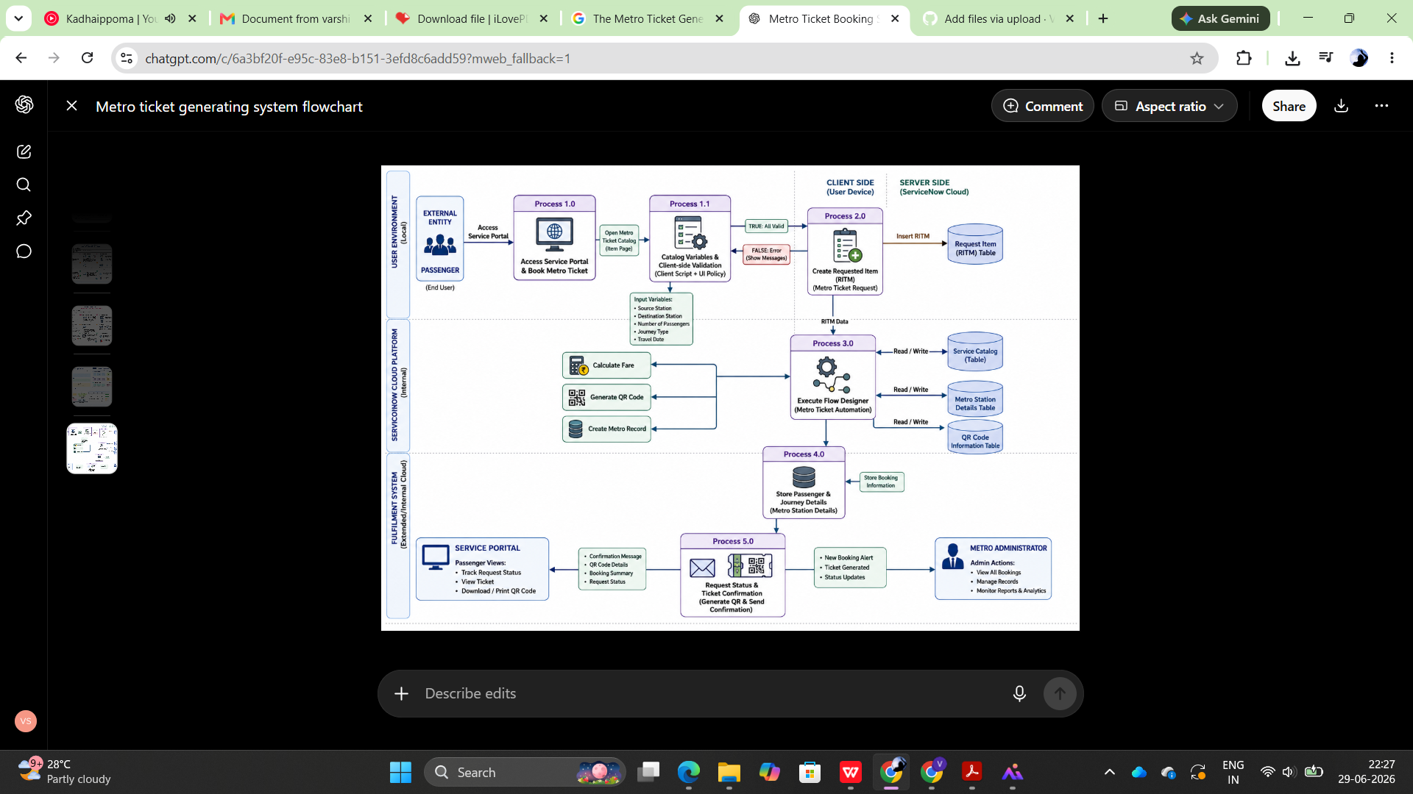

User Stories
The following user stories describe the functional requirements of the Metro Ticket Generating System from the perspective of passengers and system administrators.

US-01 | As a passenger, I want to access the Metro Ticket Booking page through the Service Portal so that I can book my ticket online. | High | 3

US-02 | As a passenger, I want to select the source and destination stations so that my journey details are captured correctly. | High | 3

US-03 | As a passenger, I want to specify the number of passengers and journey type so that the fare is calculated accurately. | High | 5

US-04 | As a passenger, I want mandatory field validation before submitting the request so that incomplete bookings are prevented. | High | 2

US-05 | As the system, I want to automatically calculate the ticket fare based on the journey details so that manual calculations are eliminated. | High | 5

US-06 | As the system, I want Flow Designer to automatically store booking information in the Metro Station Details table so that records are maintained securely. | High | 5

US-07 | As the system, I want to generate QR code details for every ticket so that ticket verification becomes easier. | Medium | 5

US-08 | As an administrator, I want to view all passenger booking records in the Metro Station Details table so that I can monitor ticket requests. | Medium | 3

US-09 | As a passenger, I want to track my submitted request through the Service Portal so that I know the booking status. | Medium | 3
US-10 | As an administrator, I want secure access to booking records using Access Controls so that only authorized users can manage passenger information. | Medium | 3

